C196 Story Board

**Main Activity -> Term Details -> Add Term ->**

**Contains WGU log and asks user if Contains list of All Terms. User can click Allows user to add a term. They can enter**

**they want to view terms. on desired term or add a term to the list. the term name, stat and end dates.**

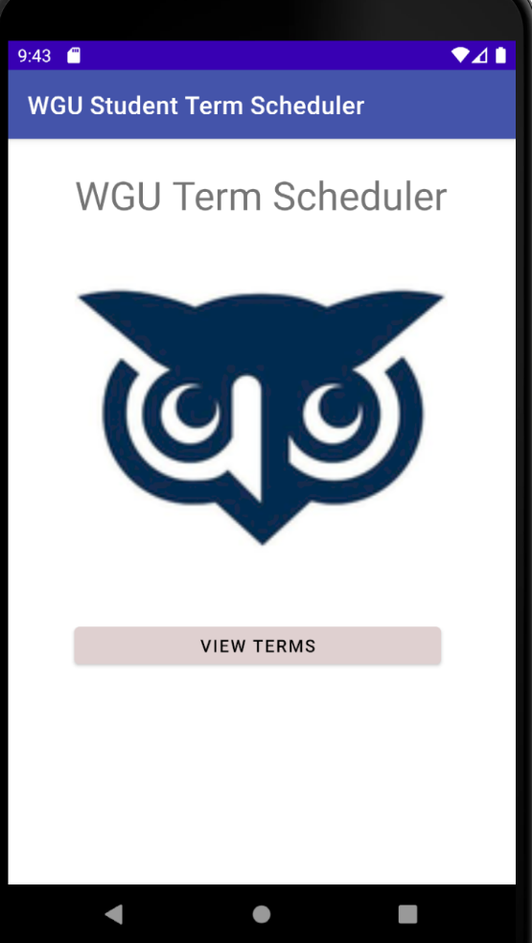 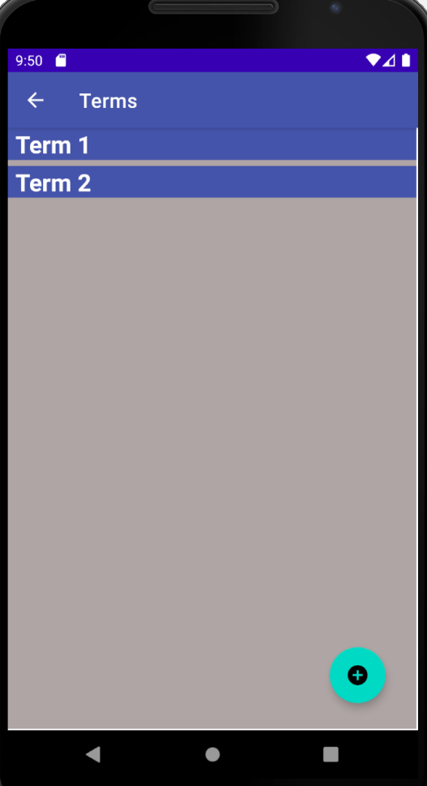 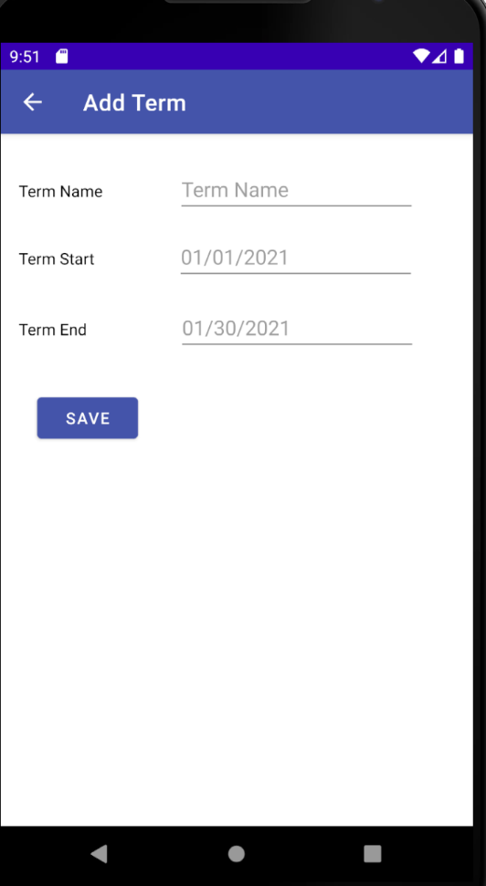

Term Details -> Term Delete ->

User can view term details, edit term details and Allows user to delete selected term.

add/ view a course that is associated with the term. Navigates user back to the Term activity.

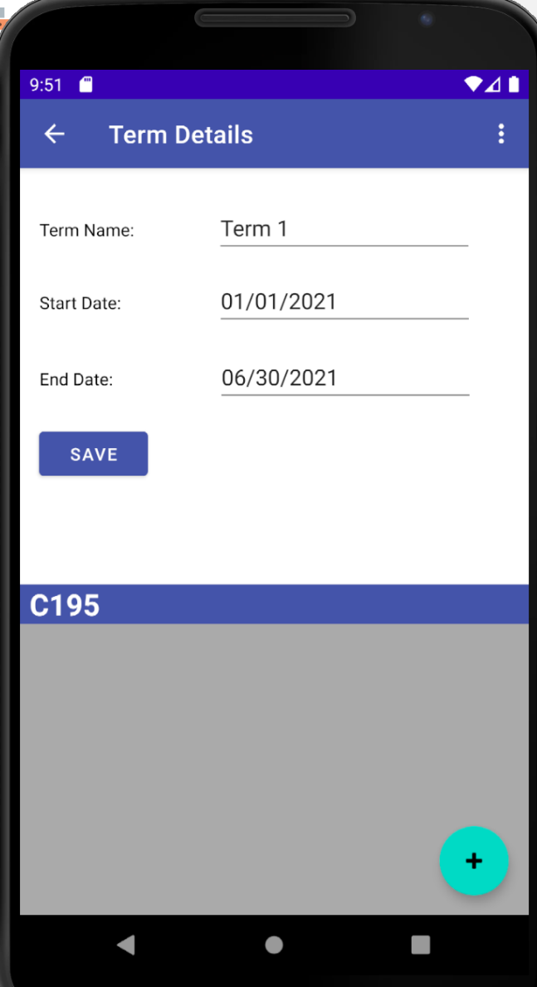 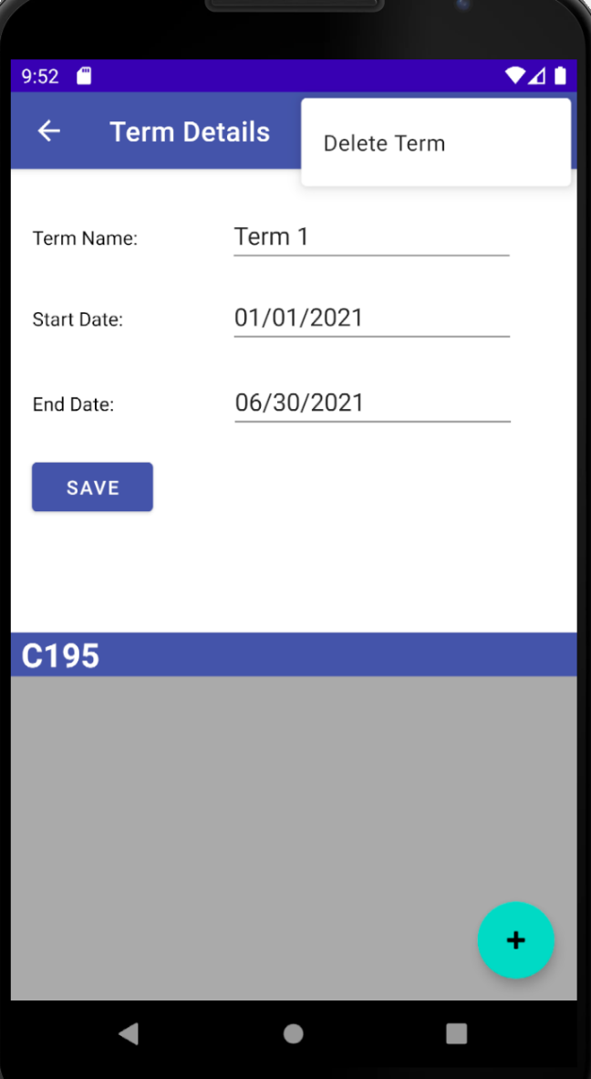

Add Course to Term Activity -> Course Detail Activity ->

Allows user to add a course to the User can view selected course details, view/ add

selected term associated Assessments and course instructors.

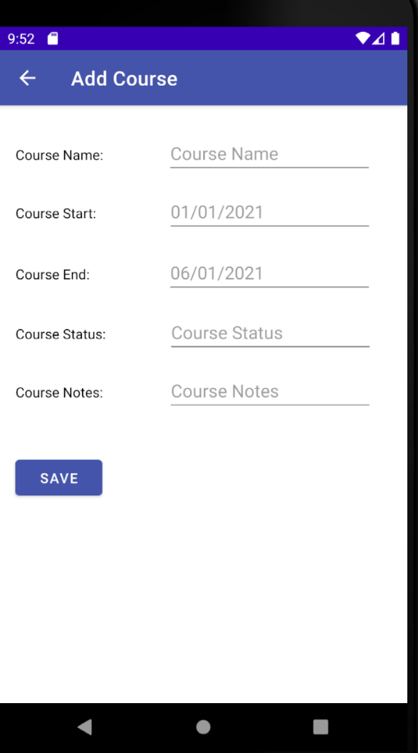 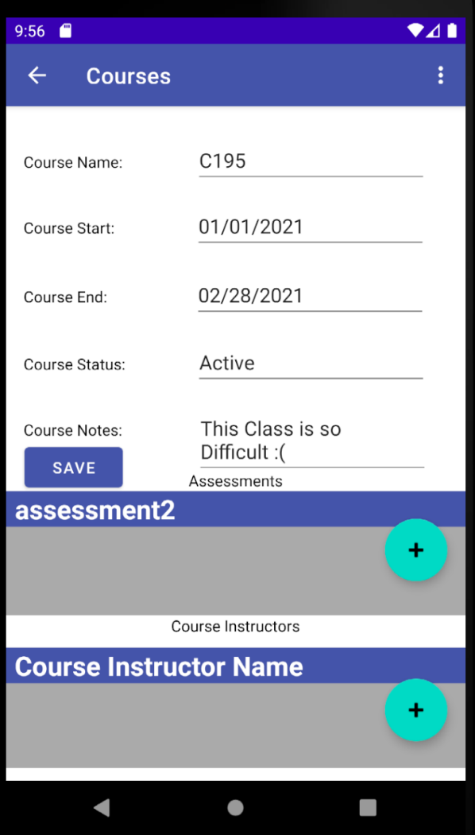

Course Details Menu -> Add Assessment Activity -> Assessment Details Activity ->

Allows user to share course notes, set Course Allows user to add an assessment to the Users can view select assessment details and

Start and end date reminters and delete course. Selected course. Make any necessary changes.

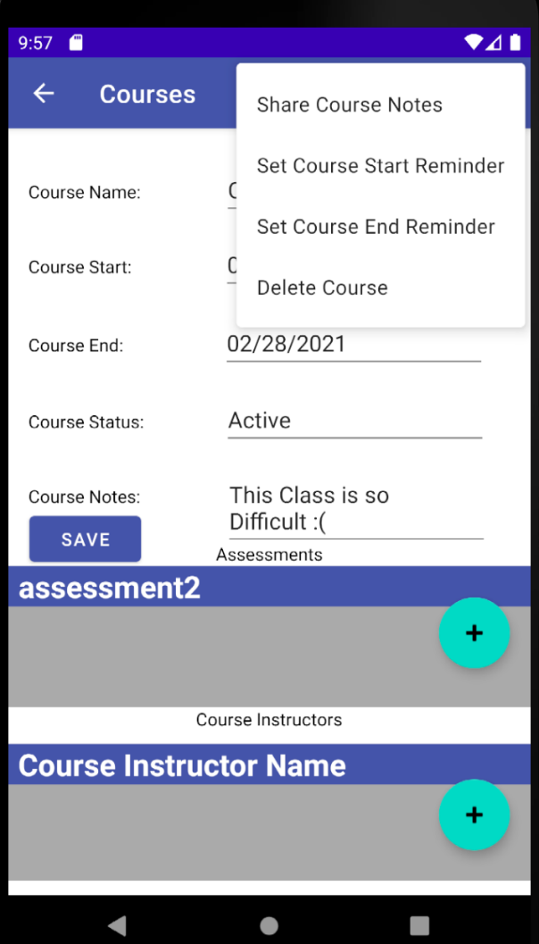 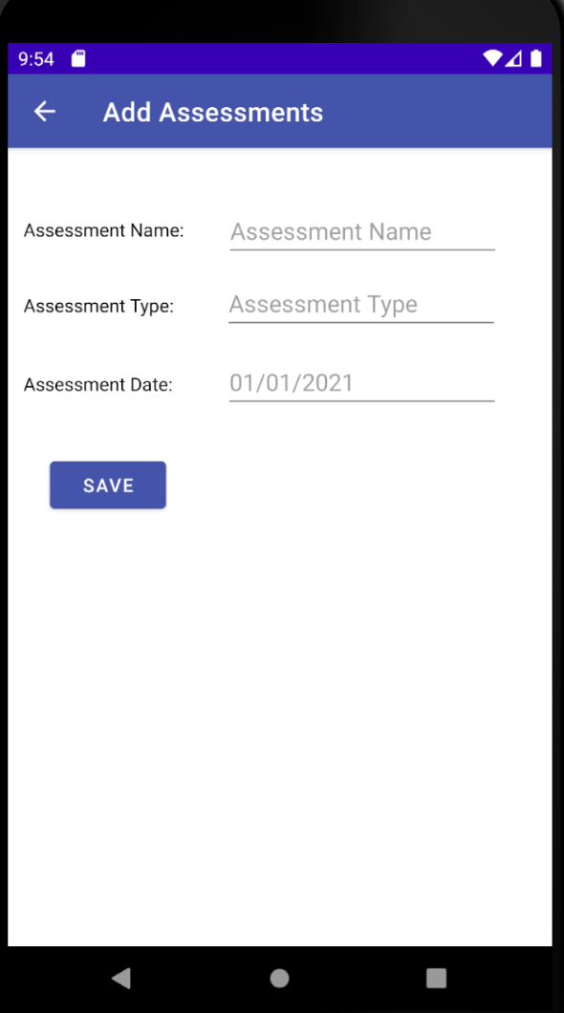 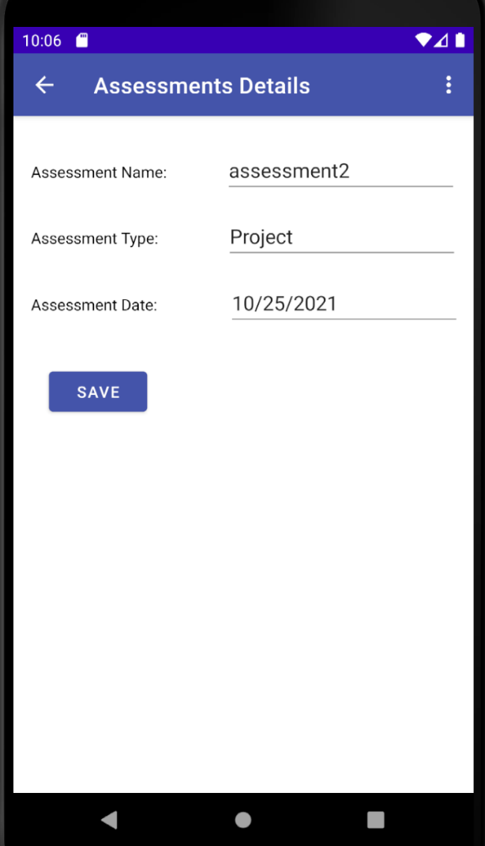

Assessment Details Menu -> Add Course Instructor Activity -> Course Instructor Details Activity ->

User can Share and delete assessments, Allows user to add a Course Instructor User can view/ edit selected course.

set assessment date remotes to the selected course.

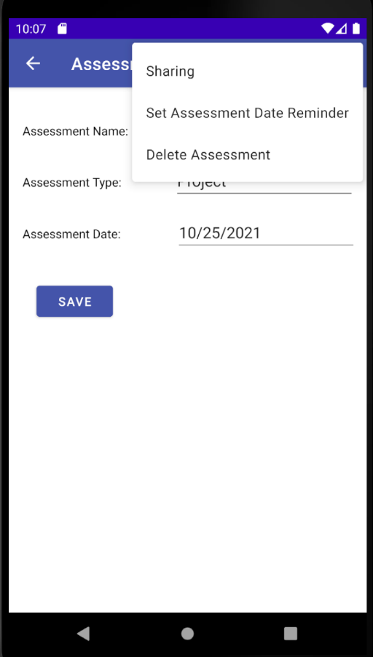 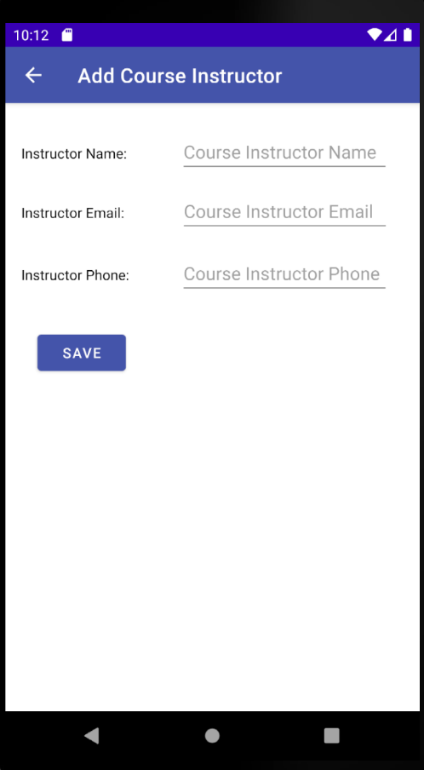 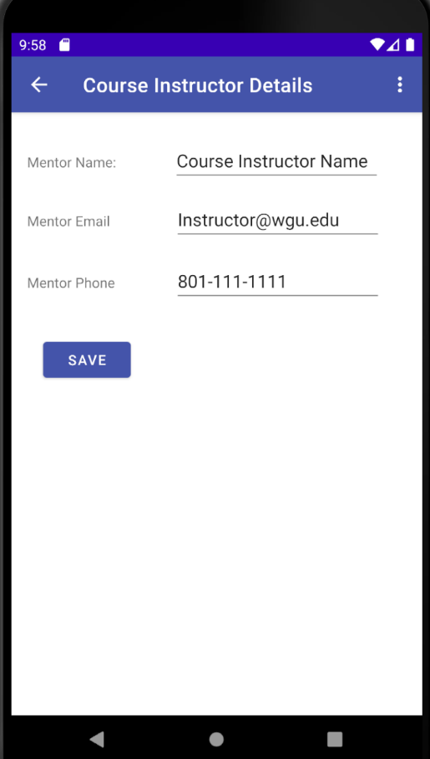

Course Instructor Menu

Allows user to delete selected course.

